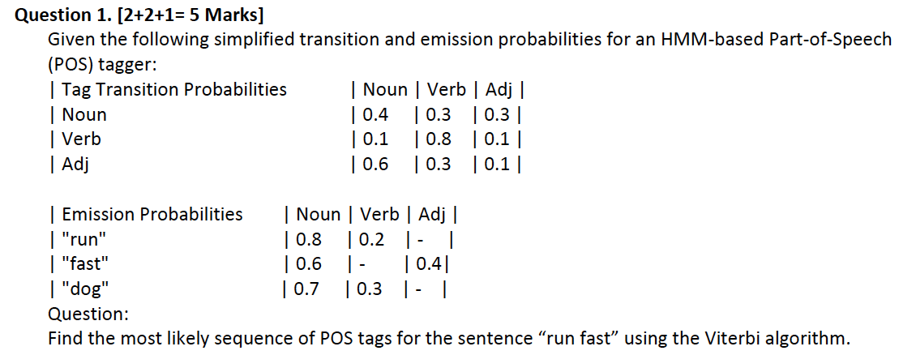

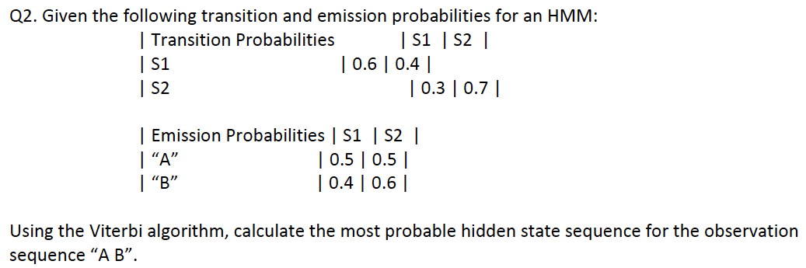

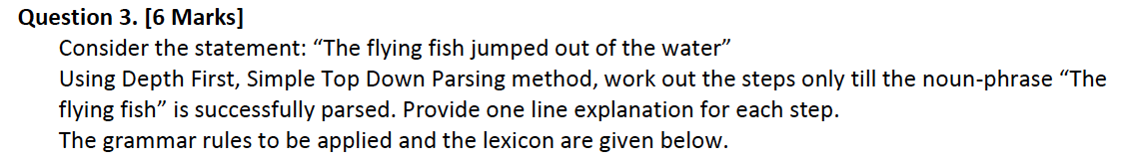
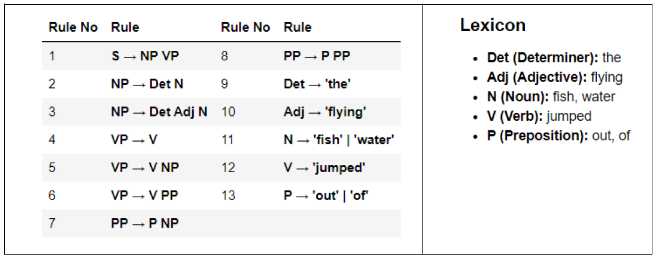

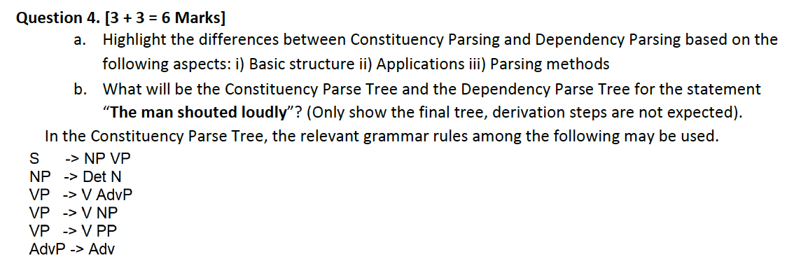

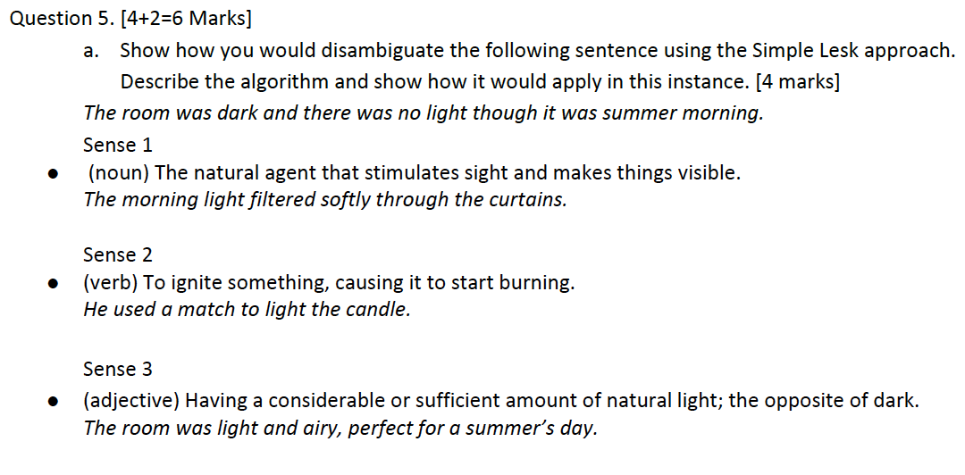
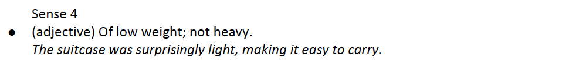
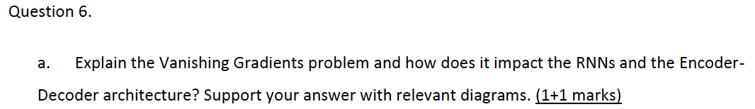

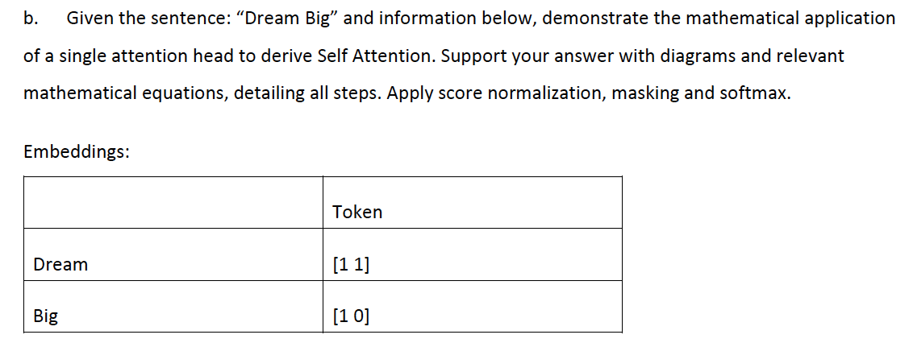

- Weight Matrix for Query Wq [0 1 1 0]
- Weight Matrix for Keys Wk [1 0 0 1]
- Weight Matrix for value Wv [1 2 2 1]
- Exp(1.41) = 4.1
- Compute all fractions only to Second Decimal place (X.XX)
